8.30 final fixes.

First, I am very happy that we found the issue with the video card. I wonder if we can identify the cards NOT to use with HS…

Final Fixes:

1. Please add Male and Child. Pls. make sure they work as advertised.
2. Please modify cutout of blend. Right now there is too much left on the sides – need to cut closer.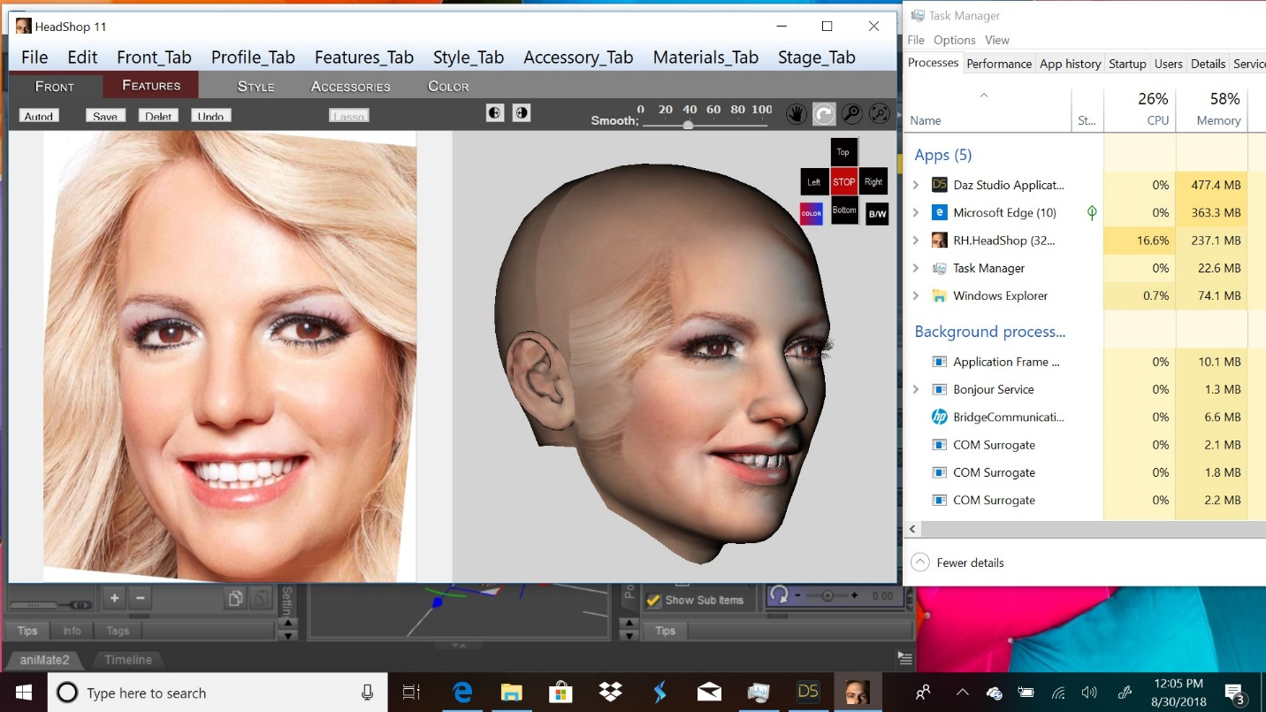
3. Need to deposit all texture files into Users/Public/Documents/My DAZ Library/Runtime/Faceshop/fs folder, including smoothed eye, mouth and teeth. Right now only face (fs.bmp) is deposited.
4. Please implement “0” position in red navigation button (replacing STOP). This is important when placing additional hair or accessory on the scene.
5. Also export additional OBJ files (hair, accessories) into Users/Public/Documents/My DAZ Library/Runtime/Faceshop/fs
6. Please nuke Profile and Stage menu entries on top bar.
7. Please rename hair slider “Size” and make it resize hair (same item as in Parts Library).

